**QUE-35.1.1- Create a employee table in Mysql and columns as Emo_id, Emp_name, Dept_name(Hadoop Developer), Emp_sal**

**ANS-35.1.1-**

**Creating table employee-**

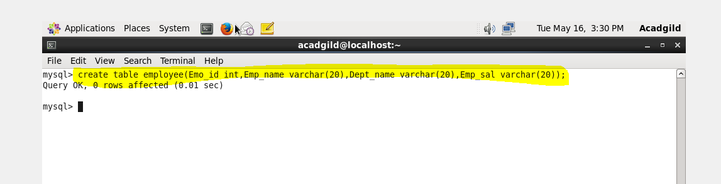

**Inserting values in table employee-**

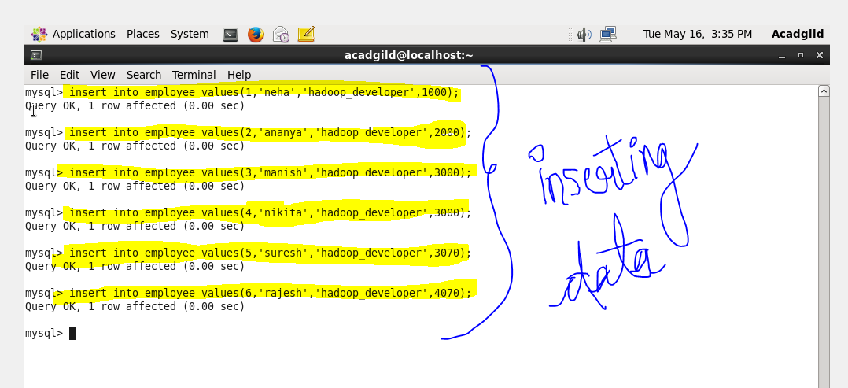

**QUE-35.1.2- Import the employee table contents into the HDFS directory using Sqoop.**

**ANS-35.1.2-**

**Creating a directory sqoop-**

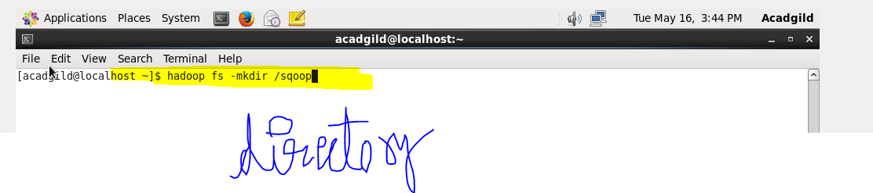

**At the browser-**

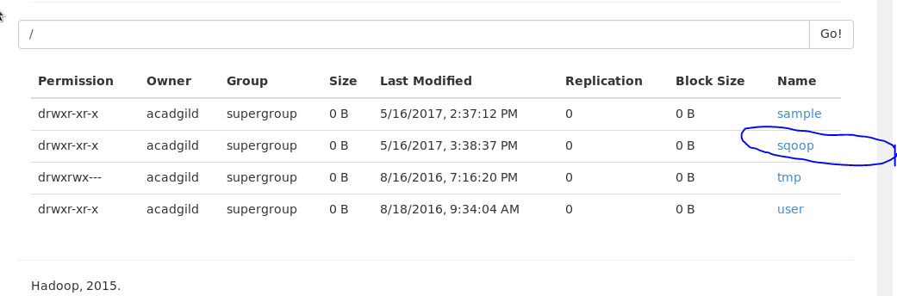

**Importing the data from mysql to hdfs directory using sqoop-**

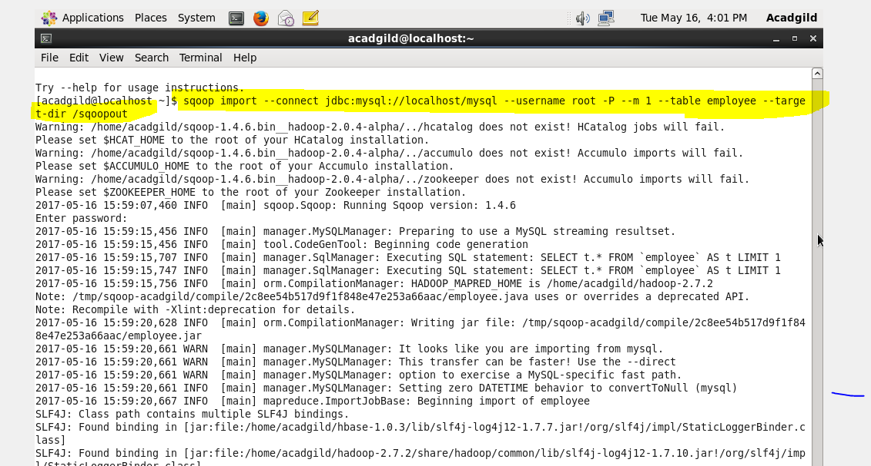

**Successfully imported-**

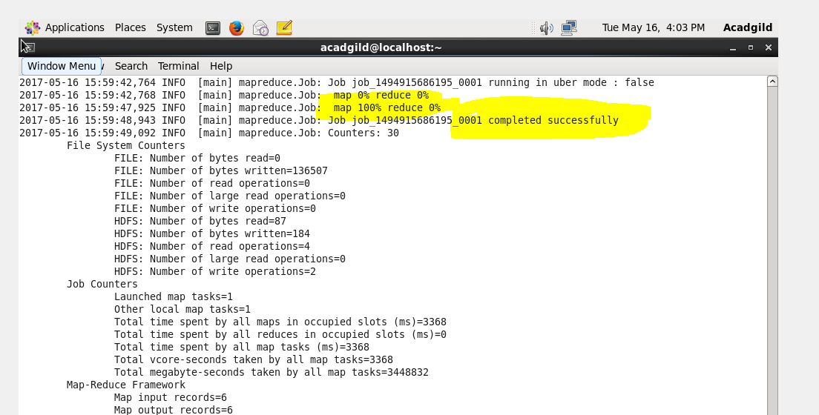

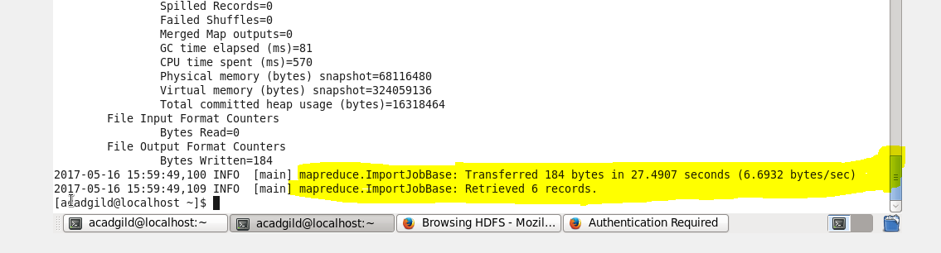

**Output-**

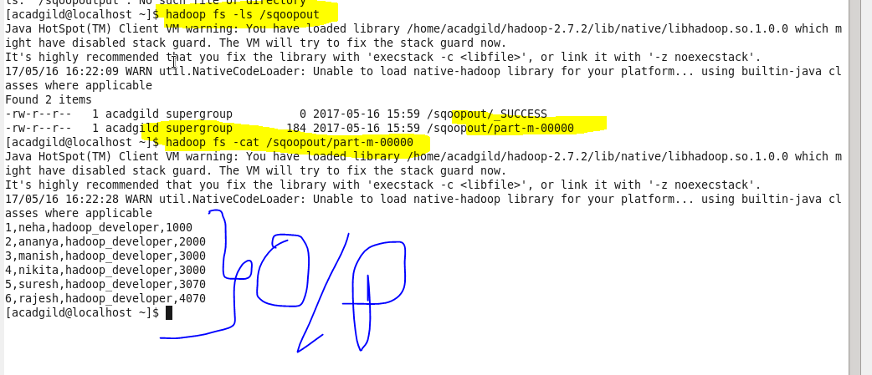

**QUE-35.1.3- Create a employee2 table in Mysql and Export employee details file from HDFS directory to Mysql table employee2 using Sqoop**

**ANS-35.1.3-**

**Creating table employee2-**

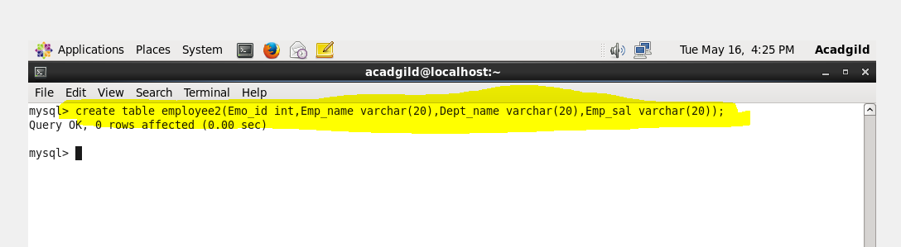

**Exporting data from hdfs to mysql-**

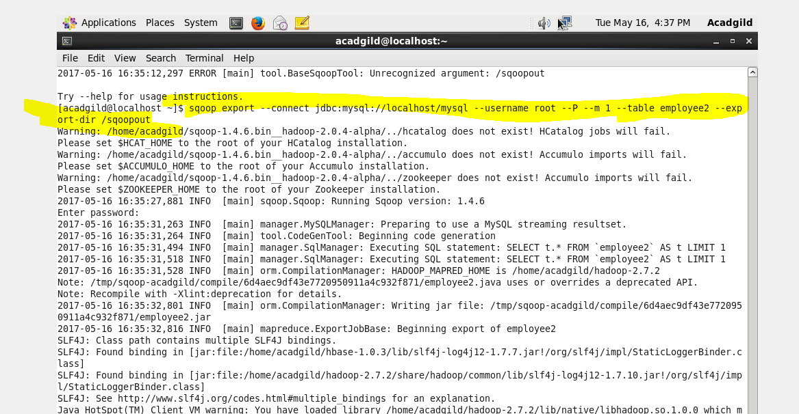

**Exported successfully-**

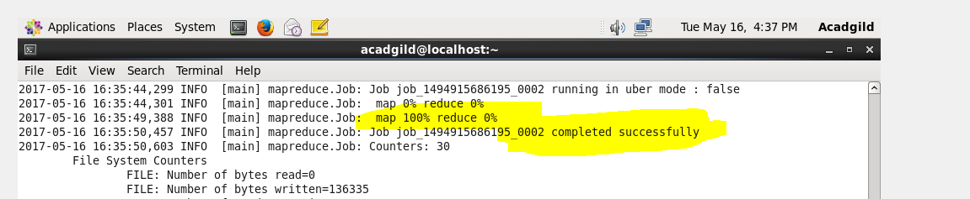

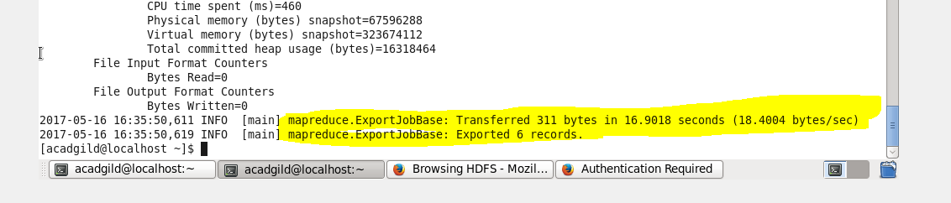

**Output -**

